Cal Poly Pomona

CS470 Game Development

Spring Quarter

2017

*****************************************************************

Documentation type: Design Specification

Project: The Farting Panda

Team: BaDkINgZ

Members: Mahmudur Khan,

Nathaniel Krueper,

Benjamin Krueper,

Chu Yiu Cheung,

Ian Stodart

Professor: Tony Diaz

*****************************************************************

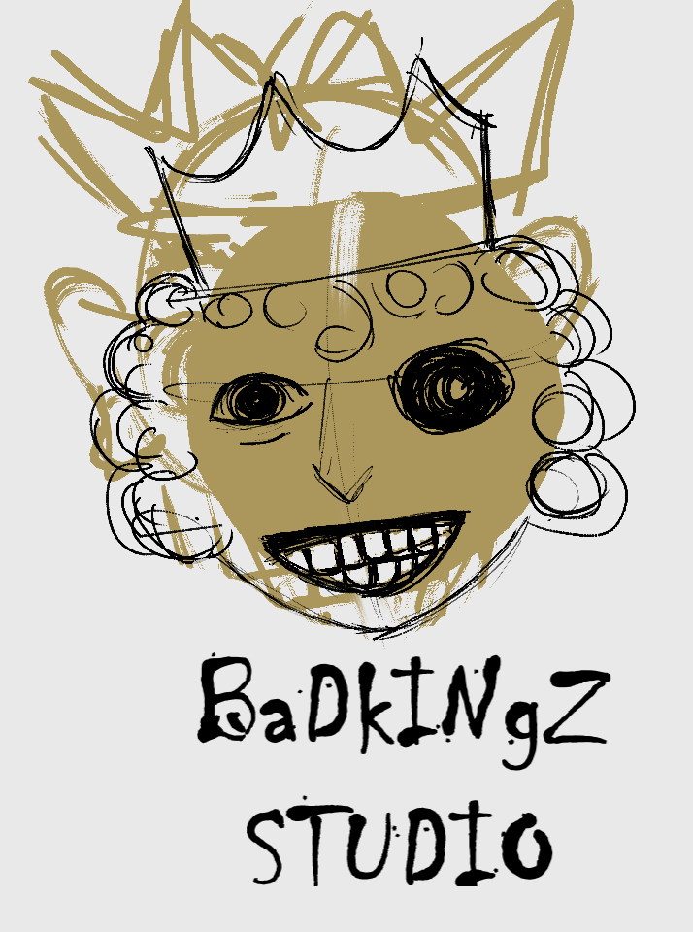

A game for: PC

Copyright 2017 [BaDkINgZ]

(* means something we need to fill out)

**Give a brief description of the game. First paragraph must get the reader interested by creating a mental image of the excitement of the game.**

The player controls a panda that spews noxious fumes to navigate levels and defeats enemies. Controls are easy to pick up, and game is speed-runner friendly.

**Through the use of illustrations and word pictures, walk the reader through the main points of the gameplay, focusing on the important aspects of the game which need communicating.**

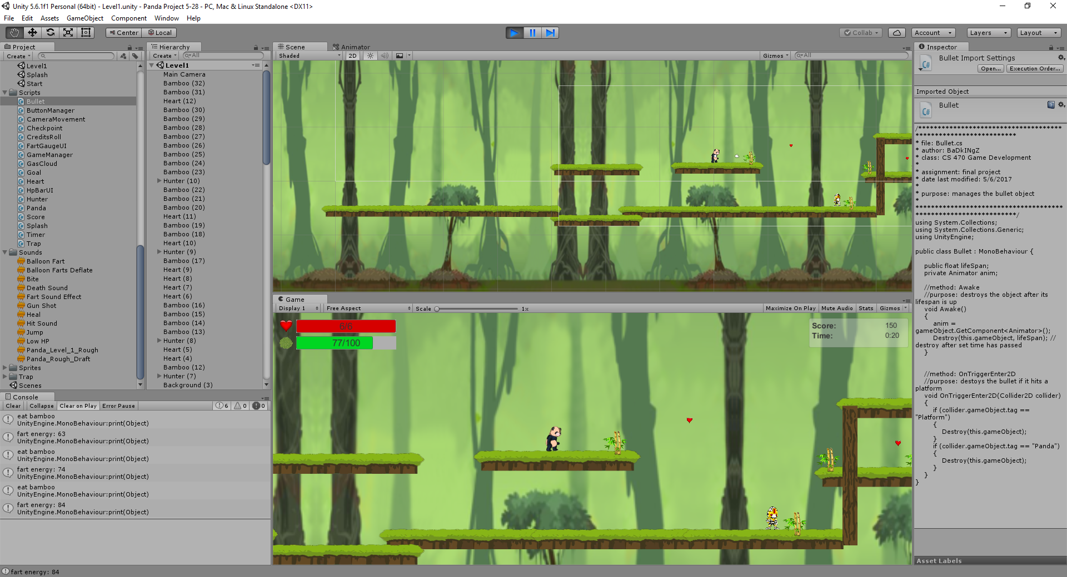

Panda:Player avatar: guide to end of level

Health: if health runs out, you restart at checkpoint

Fart energy: used to attack, reach high platforms, go fast

Bamboo: restores fart energy

Heart: restores health

Hunter: shoots player. Use farts to defeat

**Basic Concept -- What is the "high concept" of the game?**

The player guides a farting panda though a 2d world to a goal, using his “ability” to fight hunters and get to high places.

**Background Story**

A panda with digestive issues sets off on a journey to find his lost love, who went to the pond for water and never came back. He finds out she was captured by hunters and attempts to rescue her.

**What is the tone? What is the basic narrative? What is the "heart" of the story?**

Overall, tone is humorous, with a classic “save your love” story

**Objective**

Rescue the pink panda from hunters

**Gameplay -- Describe the way the game works, from beginning to end.**

A basic 2d platformer where the player uses farts to help reach platforms and fight enemies.

**\*title screen, options, other screens, ect**

**Describe the start scene and what happens next.**

After pressing play, you are immidiately placed in the first level.

**Describe the A.I. of the computerized opponent(s)**

Hunters patrol the platform they’re standing on. They turn around if they reach the edge of the platform or bump into eachother. When the player is in their line of sight, they stop moving and fire projectiles at the player at a constant rate. If the player leaves their line of sight, they will stay still for a short time looking for him, then give up and resume patrolling

**What is the planned interface?**

Main Menu, information displays during gameplay, and a win screen when the level is completed

**What is the planned perspective**

3rd person

**What is the basic interactive structure?**

Levels

**\*What is the "heart" of the gameplay?** Using resources to defeat/get around enemies

**How difficult is the game?**

Easy to Mid-easy

**How long will it take the average player to complete?**

2-5 minutes

**Characters**

Panda, Pink Panda, hunters

**World**

Bamboo jungle

**Controls**

A and D keys: move left/right (faces left/right too)

W key: Fart up

S Key: fart forwards

P Key: Pause game

Spacebar: jump

Left Shift: big fart in place

**Describe the on-screen interface**

Health and the amount of gas you have are displayed on the side of the screen in the form of a filled rectangle. Score is displayed in the upper right corner as text. A simple menu is shown at the start, with buttons for Play, Credits, and Exit

**Describe all menus in detail, and chart out the "shell" structure**.

Splash screen that shows up for a few seconds

Main menu with buttons for “Play” and “Exit”

Win screen when you complete the level

**Graphics** -- Describe the general style of the graphics.

Cartoon

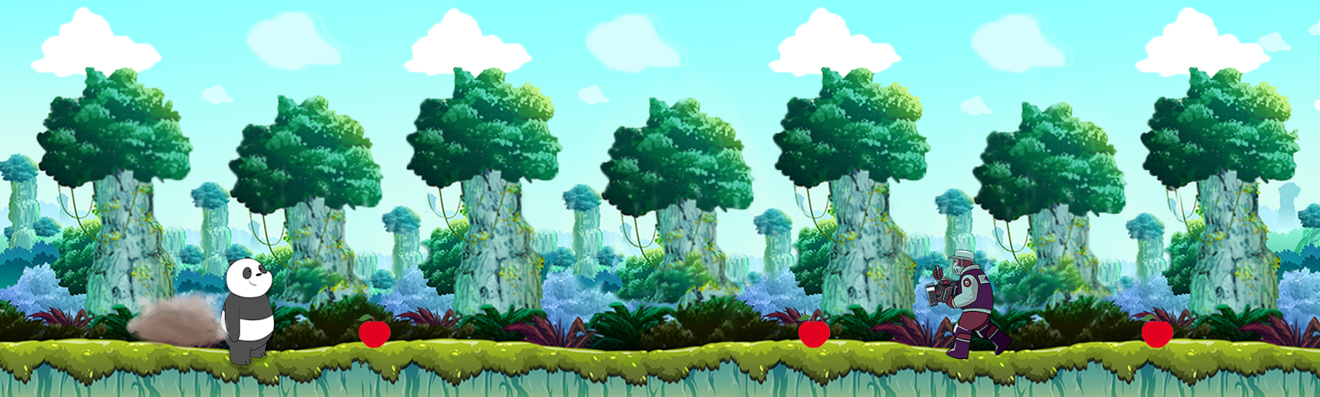

**Music**

Custom music with a medieval Chinese theme

**Sounds**

Fart: a little ‘toot’

Continuous fart: sounds like a deflating balloon.

Eat bamboo:a chomping sound

Hunter Shoot:

Panda Hurt:

Panda Death:

Collect heart:

walking/landing sounds

**Main Menu**:

Play Game

Exit Game

**Pause menu:**

Main menu: go back to menu. Progress is not saved

Restart: restart level from beginning

Quit Game: exit application

**Basic movement:**

The panda will move left/right, at a set speed when the player presses a/d. He will accelerate downward if airborne with a maximum vertical speed. Pressing S will make the panda fart in the opposite direction he’s facing, and pressing W will make him fart upward. Pressing the left shift key will make the panda fart a giant gas cloud all around him. See the fart mechanic for more info. With the spacebar, the player can make the panda jump if he’s on a platform.

**The fart Mechanic:**

Farting will propel the panda in the direction he’s facing. A green cloud of gas will also be “emitted” from the panda, travelling in the opposite direction until it hits a wall or enemy. This means to attack horizantally, the player must be facing away from the enemy. The cloud can push movable objects back. Farts can also be used to double jump.

Holding the W or S key will make the panda fart continuously. If facing up, the propulsion will be enough to keep the panda airborne for a short time

Pressing Shift will emit a giant gas cloud that does extra damage, at the cost of more fart energy. Will not move the panda.

You can only fart if you have enough “gas” stored up. You can eat bamboo to obtain gas. If you have too much gas stored up, you could randomly let it out automatically. The higher you are over this limit, the more likely is is that will will fart automatically. a gas meter will tell you when you are in this range.

You will accumulate gas automatically, faster if you are at under 10% of your maximum capacity, just in case you’re out of gas and need it to pass an obstacle

**Items**

Bamboo: found throughout level, does not float in the air. Collecting will fill “gas” meter, award small amount of points.

Heart: found throughout level, can float in mid-air. Collecting them restores a small amount of health

Red flag: checkpoint. Turns yellow when activated

Pink Panda: the goal of the level. Touching triggers the end of the level and a short cut-scene where the she jumps up and down.

**Enemies**

Hunter: will walk left/right and turn around if they are at the edge of a platform or bump into another enemy (like red koopas in Mario). They will stop and shoot slow moving projectiles at the panda if they can see him. The projectiles are shot in a straight line from a rifle that points at the panda if the hunter can see him. The hunter’s contact with the player does not cause damage. The player can jump on them to defeat them, but will not bounce off them. Low health, low attack

Bear trap: causes big damage the first time it’s stepped on. Cannot be destroyed. Has different pictures for sprung and unsprung.

**Score**

Determined by hearts collected, enemies defeated, level completion.

**Obstacles**

Floor: has a grass texture. Length is greater than height.

Wall: has a wood texture. Height is greater than length

**Background images**

Bamboo jungle